Certification of Publication

State of California
County of San Luis Obispo
I hereby certify that I am the principal clerk of the printer of The Paso Robles Press and The Atascadero News, newspapers of general Circulation by The Superior Court of the County of San Luis Obispo, State of California: that the notice of which the annexed is a printed copy (set in type not smaller than nonpareil), has been published in each regular and entire issue of said newspapers and not in any supplement thereof on the following dates to wit:

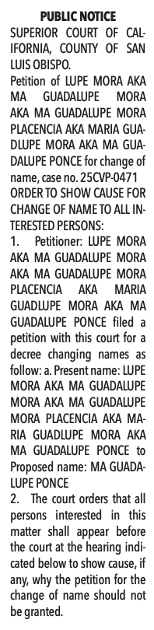

Legal Notice:
ORDER TO SHOW CAUSE FOR
CHANGE OF NAME:

MA GUADALUPE PONCE

Dates Published:
3/19, 3/26, 4/2, 4/9/2026
I certify (or declare) under penalty of perjury that the forgoing is true and correct.

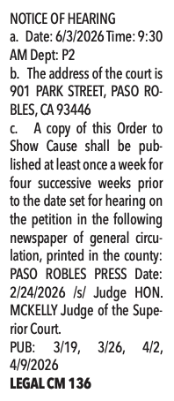

Executed on: 4/9/2026
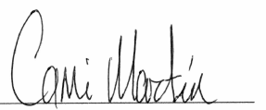
In Atascadero, California

Legal Clerk, Cami Martin
The Atascadero News and
The Paso Robles Press

